Table of Contents

1. MOBILE APP WIREFRAME 2

1.1. MOBILE SCREEN 2

1.2. MARKETS SALES APP HOME SCREEN 2

1.3. BUY BUS TICKET MODULE 3

1.4. SELL MODULE 5

1.5. RESET PIN MODULE 6

1.6. LOGIN MODULE 7

1.7. VIEW SALES MODULE 8

1.8. CHECK ACCOUNT BALANCE MODULE 9

1.9. ORDER STOCK MODULE 10

1.10. CHANGE PIN MODULE 12

2. WEB APPLICATION WIREFRAME 13

2.1. LOGIN SCREEN 13

2.2. HOME SCREEN 14

2.3. USER MANAGEMENT MODULE 14

2.3.1. USER ROLES 14

2.3.2. SYSTEM USERS 16

2.4. TRADER MANAGEMENT MODULE 18

2.5. CONFIGURATIONS MODULE 20

# MOBILE APP WIREFRAME

In order to demonstrate what interface elements will exist on key screen of the Markets Sales Mobile app, we used mobile wireframe. A mobile wireframe, also known as screen blueprint, is a visual guide that represents the skeletal framework of a mobile app. It is a critical part of the interaction design process. It can also be used to create the global and secondary navigation to ensure the terminology and structure used for the mobile app meets user expectations. The section below presents the key screen of the Markets Sales Mobile app.

# 

## MOBILE SCREEN

This wireframe shows the Markets Sales Mobile app icon on the mobile device.



Fig. 1.1. Markets Sales Mobile app icon on the mobile device

## MARKETS SALES APP HOME SCREEN

The wireframe shown Fig.1.2 shows the Markets Sales Mobile app home screen.



Fig. 1.2. Markets Sales Mobile App Home Screen

## BUY BUS TICKET MODULE

The wireframes under this section show how the trader navigates in the module to buy a bus ticket. The trader accesses this module without signing in.

Buy Bus Ticket First screen shown in fig. 1.3 appears when the trader selects Buy Bus Ticket on the Markets Sales Mobile app home screen.



Fig. 1.3. Buy bus ticket first screen

The buy bus ticket second screen shown in fig. 1.4 appears when the trader selects submit on the Buy Bus Ticket home screen.



Fig. 1.4. Buy bus ticket second screen

The buy bus ticket third screen shown in fig. 1.5 appears when the trader selects make payment on the Buy Bus Ticket home screen.



Fig. 1.5. Buy bus ticket third screen.

The buy bus ticket fourth screen shown in fig. xx appears when the trader selects pay on the Buy Bus Ticket home screen.



Fig.1.5. Buy bus ticket fourth screen.

## SELL MODULE

The wireframes under this section show how the trader navigates in the module to sell goods. The trader accesses this module without signing in.

Sell module first screen shown in fig. 1.6 appears when the trader selects sell on the Markets Sales Mobile app home screen.



Fig. 1.6. Sell module first screen

Sell module second screen shown in fig. 1.7 appears when the trader selects pay on the Sell module screen.



Fig. 1.7. Sell module second screen

## RESET PIN MODULE

The wireframes under this section show how the trader navigates in the module to reset (recover) the pin. The trader accesses this module without signing in.

Reset pin module first screen shown in fig. 1.8 appears when the trader selects Reset pin on the Markets Sales Mobile app home screen.



Fig. 1.8. Reset pin module first screen

Reset pin module second screen shown in fig. 1.9 appears when the trader selects submit on the reset pin module screen.



Fig. 1.9. Reset pin module second screen

Reset pin module third screen shown in fig. 2.0 appears when the trader selects save on the reset pin module screen.



Fig. 2.0. Reset pin module third screen

## LOGIN MODULE

The wireframes under this section show how the trader navigates to logon to the Markets Sales Mobile app.

Login screen shown in fig. 2.1 appears when the trader selects Login on the Markets Sales Mobile app home screen.



Fig. 2.1. Login screen

The trader’s home screen shown in fig. 2.2 appears when the trader successful logons on the Markets Sales Mobile app.



Fig. 2.2. Trader’s home screen shown.

## VIEW SALES MODULE

The wireframes under this section show how the trader navigates to view sales. The trader must be logged in to accesses this module.

The view sales module first screen shown in fig. 2.3 appears when the trader selects view sales on the Trader’s Home screen.



Fig. 2.3. View sales module first screen.

The view sales module second screen shown in fig. 2.4 appears when the trader selects view on the View sales screen.



Fig. 2.4. View sales module second screen

## CHECK ACCOUNT BALANCE MODULE

The wireframes under this section show how the trader navigates to check the account balance. The trader must be logged in to accesses this module.

The check account balance module first screen shown in fig. 2.5 appears when the trader selects check account balance on the Trader’s Home screen.



Fig. 2.5. Check account balance module first screen.

The check account balance module second screen shown in fig. 2.6 appears when the trader selects check on the check account balance screen.



Fig. 2.6. Check account balance module second screen

## ORDER STOCK MODULE

The wireframes under this section show how the trader navigates to order stock from the supplier or another trader. The trader must be logged in to accesses this module.

The order stock module first screen shown in fig. 2.7 appears when the trader selects order stock on the Trader’s Home screen.



Fig. 2.7. Order stock module first screen

The order stock module second screen shown in fig. 2.8 appears when the trader selects find on the order stock screen.



Fig. 2.8. Order stock module second screen

The order stock module third screen shown in fig. 2.9 appears when the trader selects pay on the order stock screen.



Fig. 2.9. Order stock module third screen

## CHANGE PIN MODULE

The wireframes under this section show how the trader navigates to change the pin. The trader must be logged in to accesses this module.

The change pin module first screen shown in fig. 3.0 appears when the trader selects change pin on the Trader’s Home screen.



Fig. 3.0. Change pin module first screen

The change pin module second screen shown in fig. 3.1 appears when the trader selects saves on the change screen.



Fig. 3.1. Change pin module second screen

1. WEB APPLICATION WIREFRAME

This section provides wireframes that demonstrates what interface elements will exist on key screens of the Markets Sale Management System web application. A wireframe, also known as screen blueprint, is a visual guide that represents the skeletal framework of an application. It is a critical part of the interaction design process. It can also be used to create the global and secondary navigation to ensure the terminology and structure used for the application meets user expectations. The section below presents the key screens of the Markets Sales Web application. Market Sales Management System Web Application will be used mainly for management tasks such as trader account management, trader sales management, Market configurations i.e. market charges, Web application User creation and so on. Its Main users will likely be Market Administrators and System Administration.

* 1. LOGIN SCREEN

This wireframe shows the Markets Sales Web application login screen. The User will have to provide their Email and Password for them to login into the system.

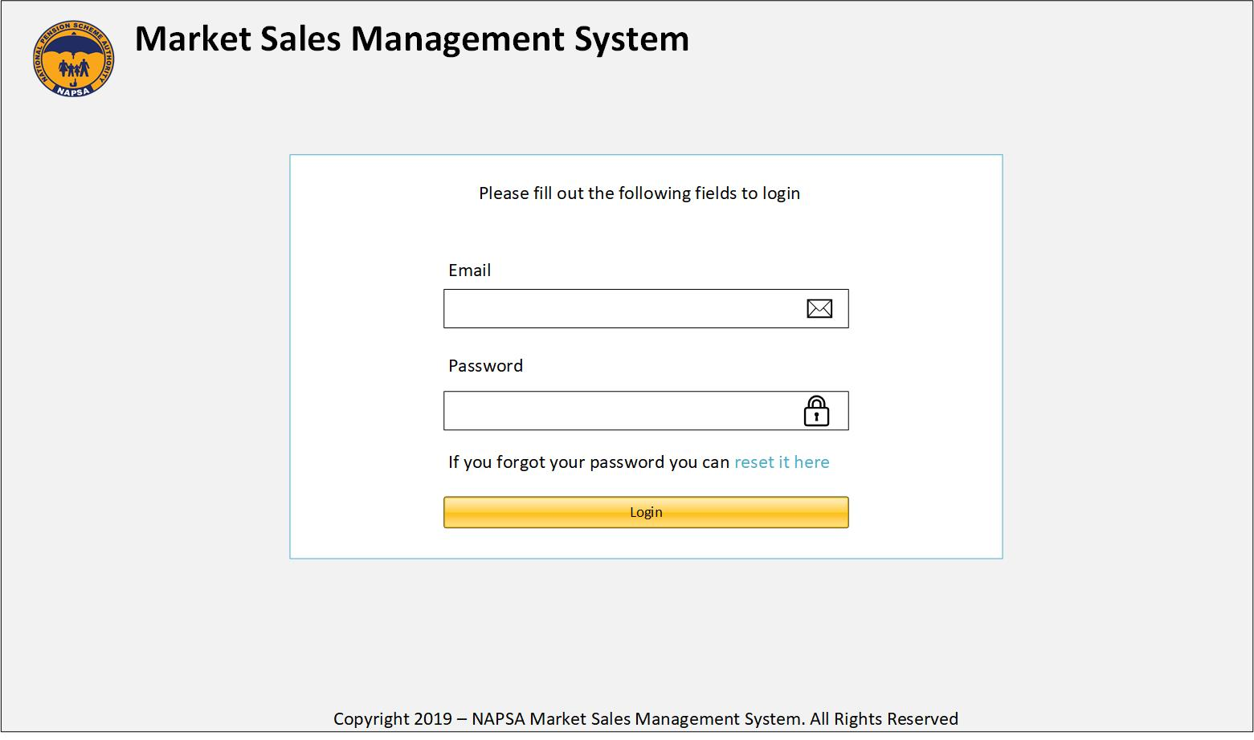

Fig. 3.2. Markets Sales Web app login screen

* 1. HOME SCREEN

The Home screen will be the landing page for a User once they have successfully logged in into the system. The page will show statistics based on the user roles. The statistics shown are likely to be agreed upon with the client.

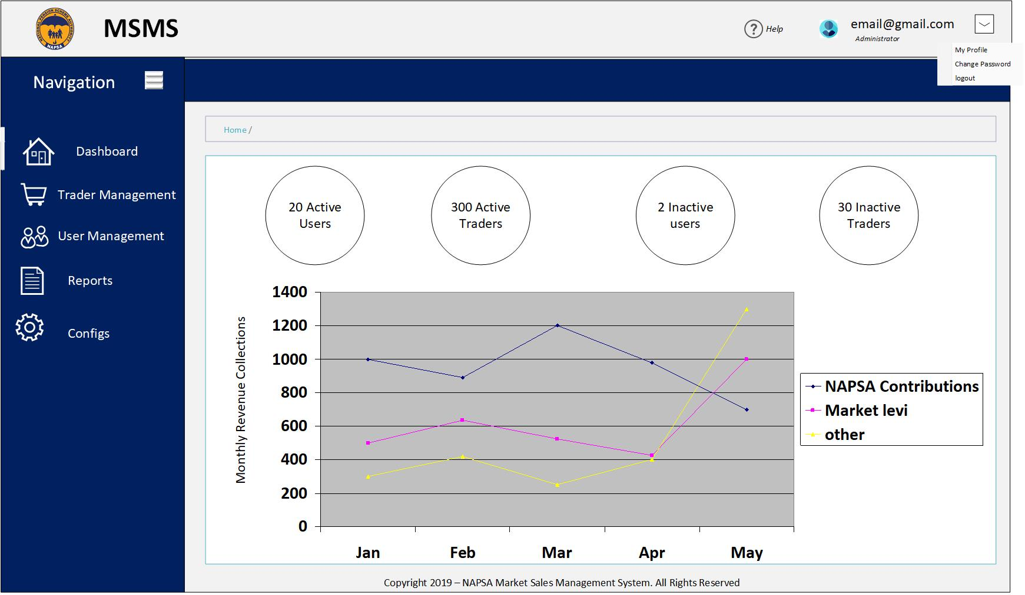

Fig. 3.3. Markets Sales web App Home Screen

* 1. USER MANAGEMENT MODULE

The User management module will be used by System Administrators to add Web Application System User Roles and System Users. The module will comprise of the User Roles module and the System User Module. The User Role module will be used to create new system user roles and assign permissions that the new role will have in the system. The User module will be used to manage system users. It will be used to create, block and edit users. The following wireframes provides the screens for the User management module.

* + 1. USER ROLES

When a User clicks on the User Roles navigation tab, the system will take them to the user roles index page as shown by below image. The index page will list all available user roles and their associated permissions that the role has. If a user clicks on the Add New Role Button, the system takes the user to add new role page from which they supply the role name, selects system permissions applicable to that role and saves. To update the name of the role, the user just clicks the role name from the index upon which an edit popup appears and they can edit the name but to edit permissions, the user clicks on the edit icon on the far right hand of the roles table on the index page.

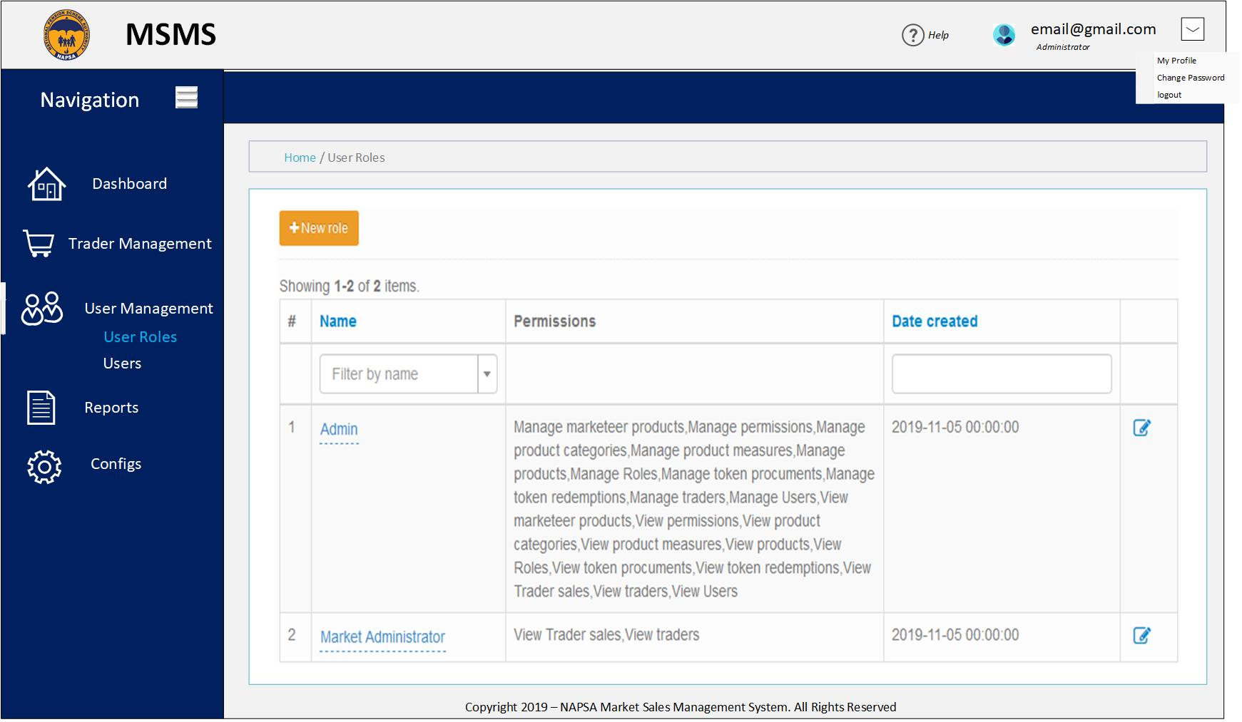

Fig. 3.4. User Roles Home page

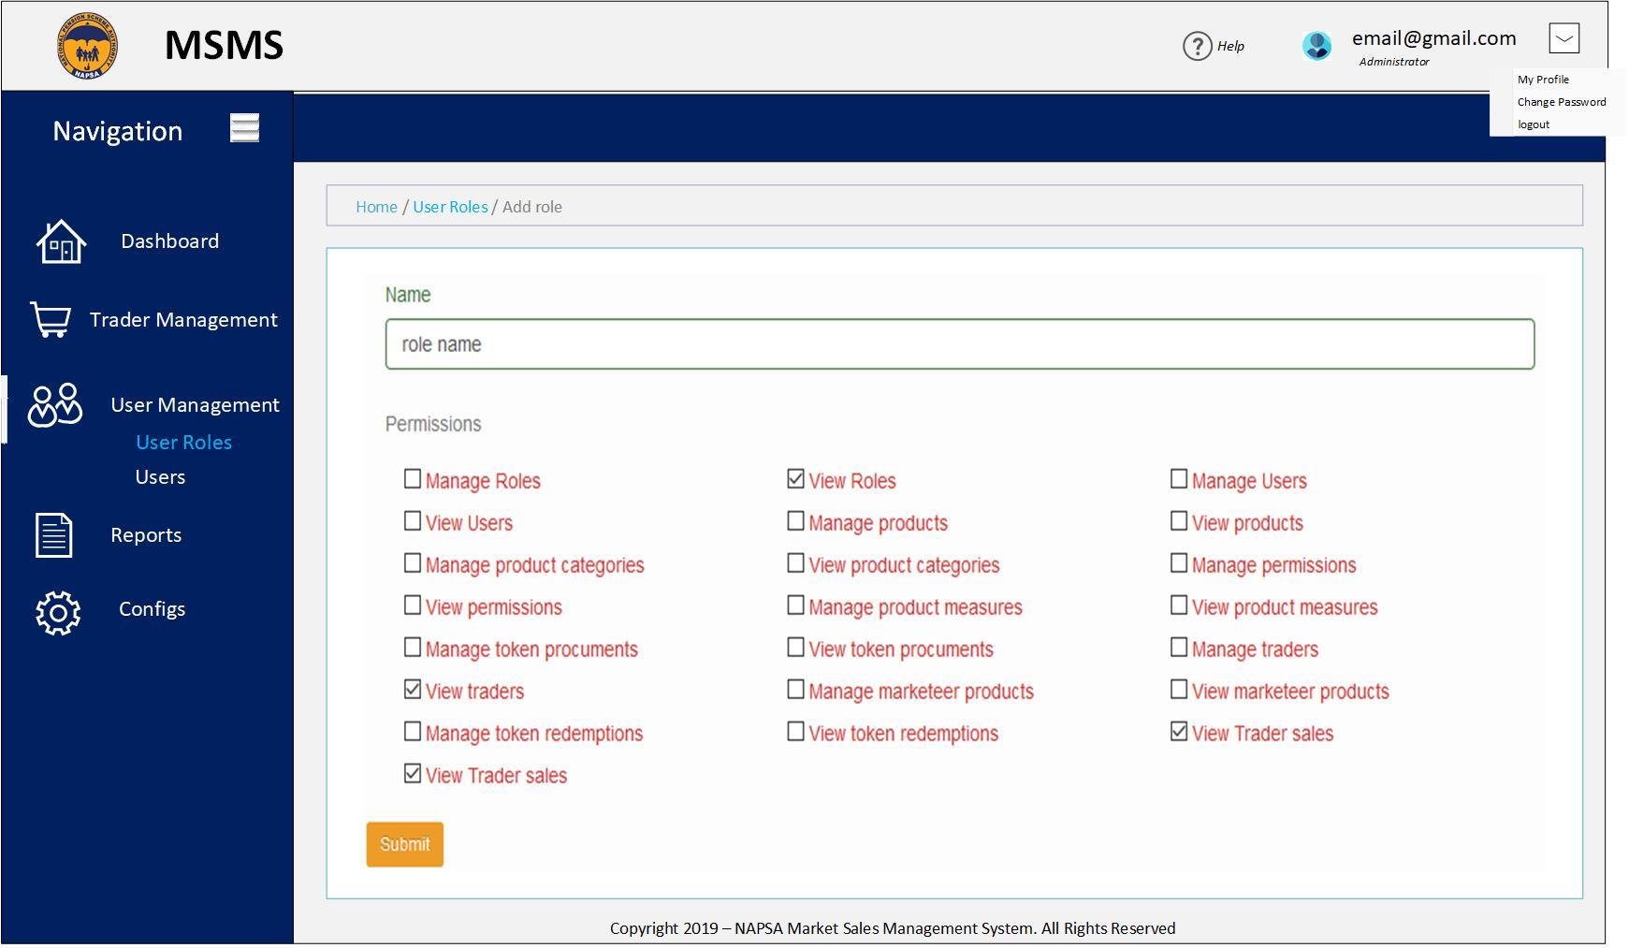

Fig. 3.5. Add User role

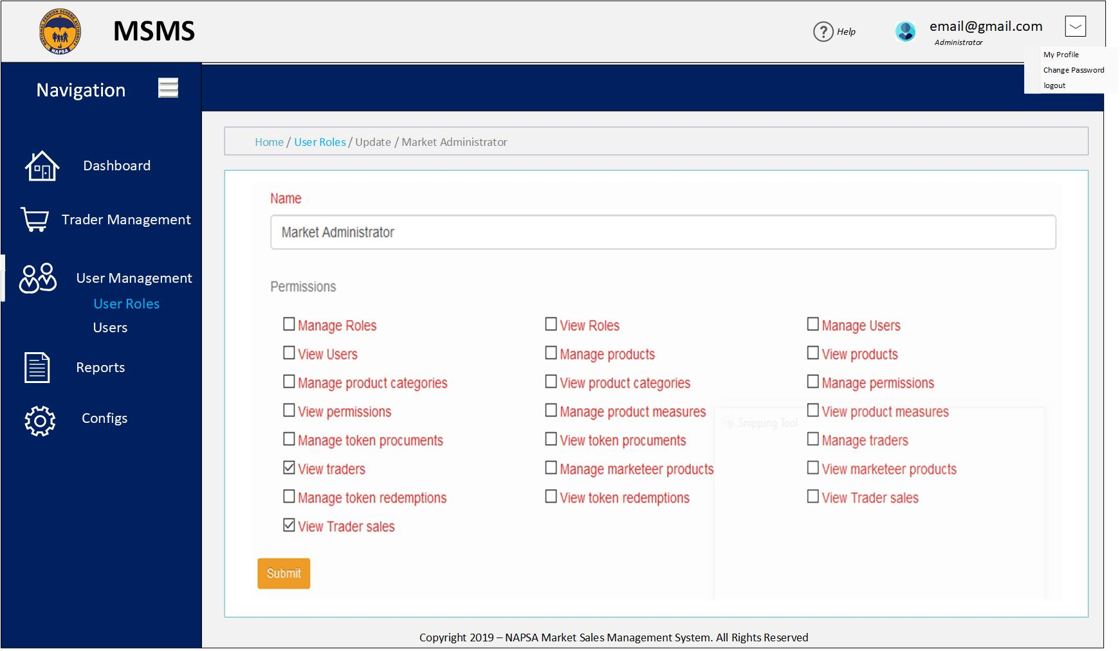

Fig. 3.6. Update User role

### SYSTEM USERS

When a user clicks on the Users tab under user management navigation tab, the system takes the user to the Users index page which lists all the users in the system. To add a user, from the index page, a user clicks on the Add User button where they are taken to the Add new user page from which they can add a user. To update user details, the user just clicks on the edit icon and they are taken to the update user details page. To view all user details, the user clicks on the view user icon and the system takes them to the view users page. The next images shows the Systems Users pages.

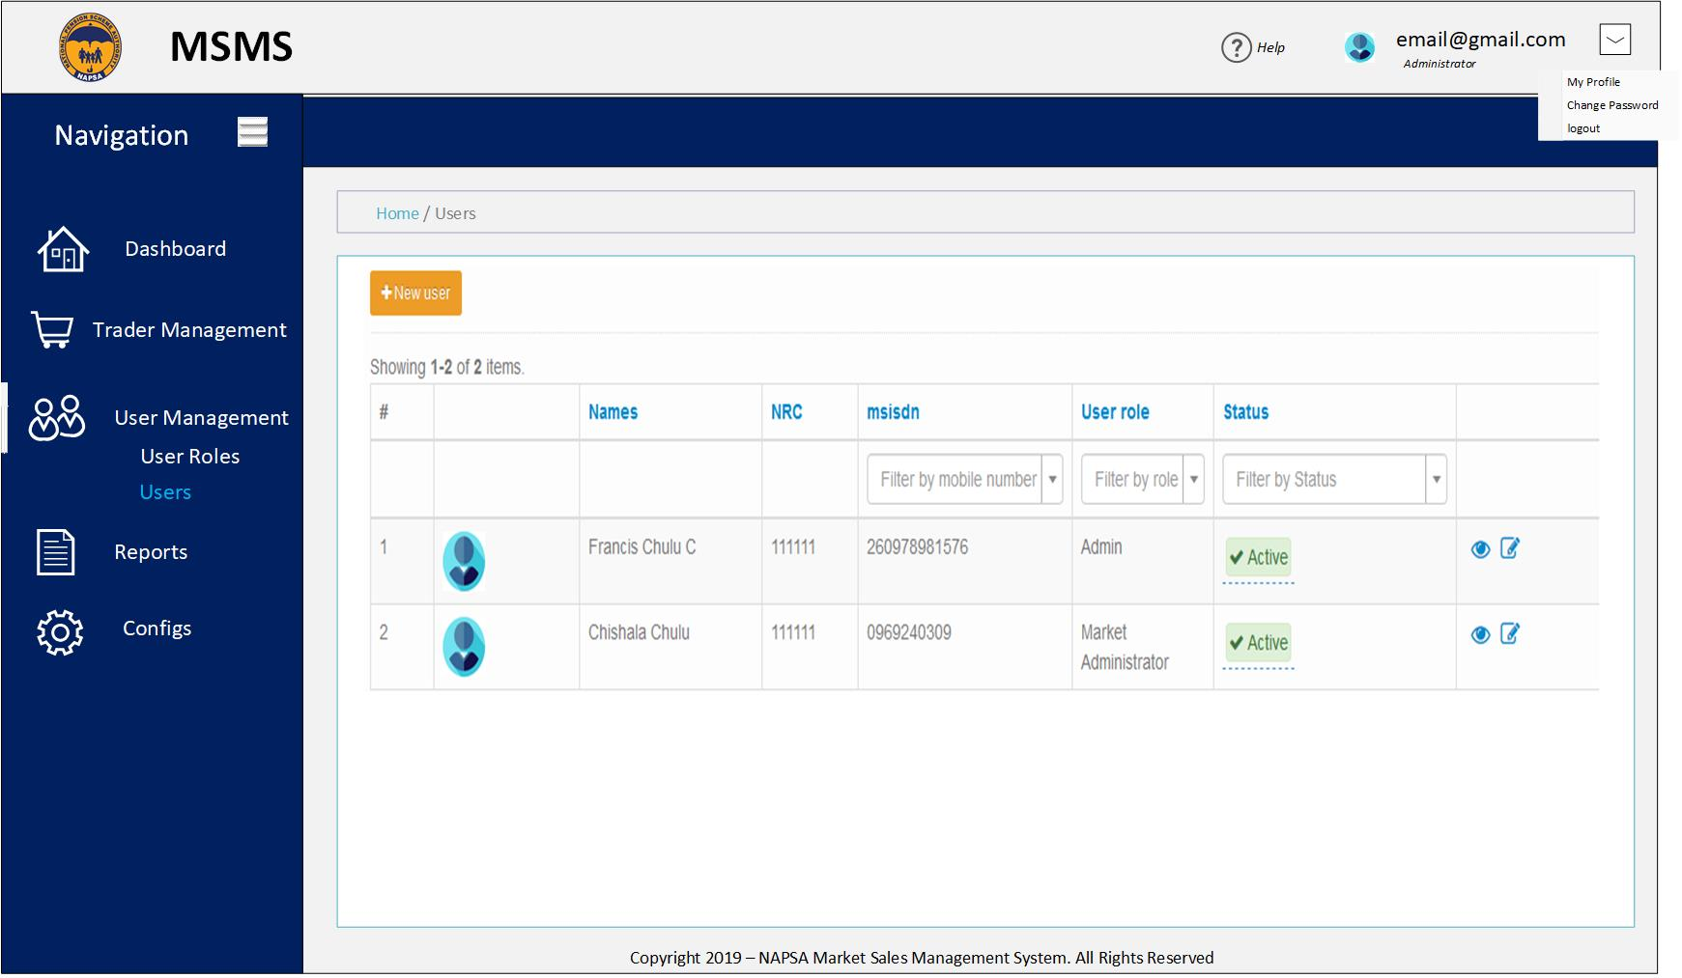

Fig. 3.7. Users home screen.

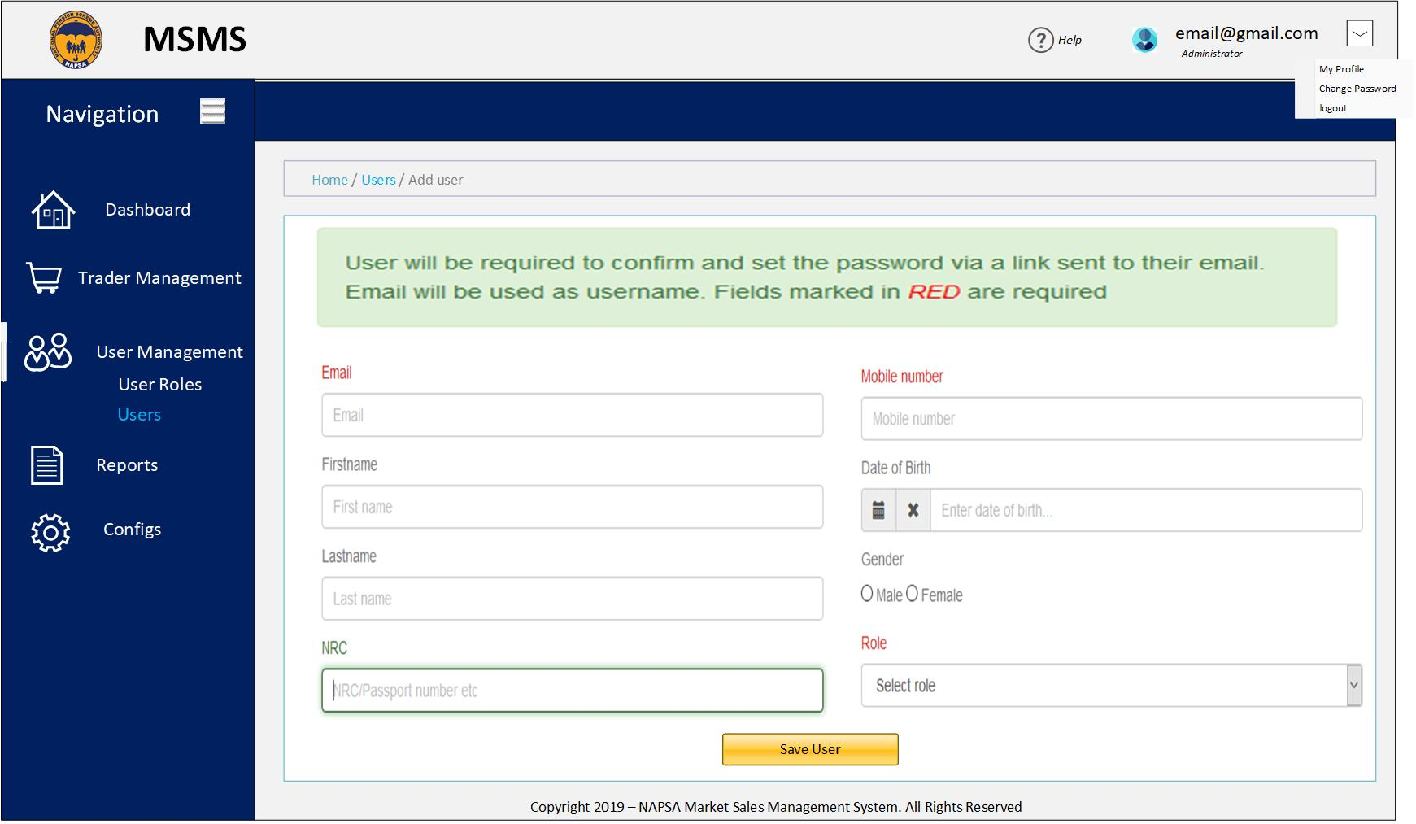

Fig. 3.8. Add User screen.

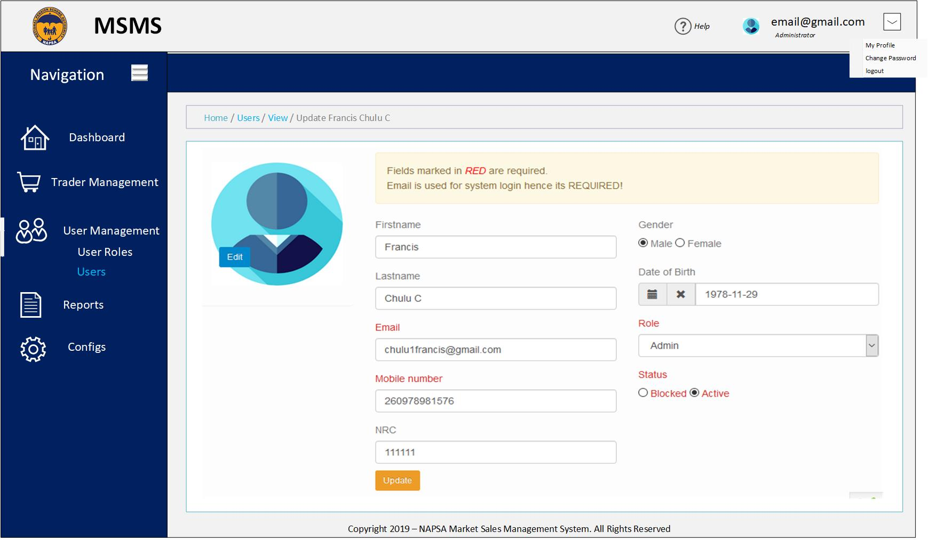

Fig. 3.9. Update User screen.

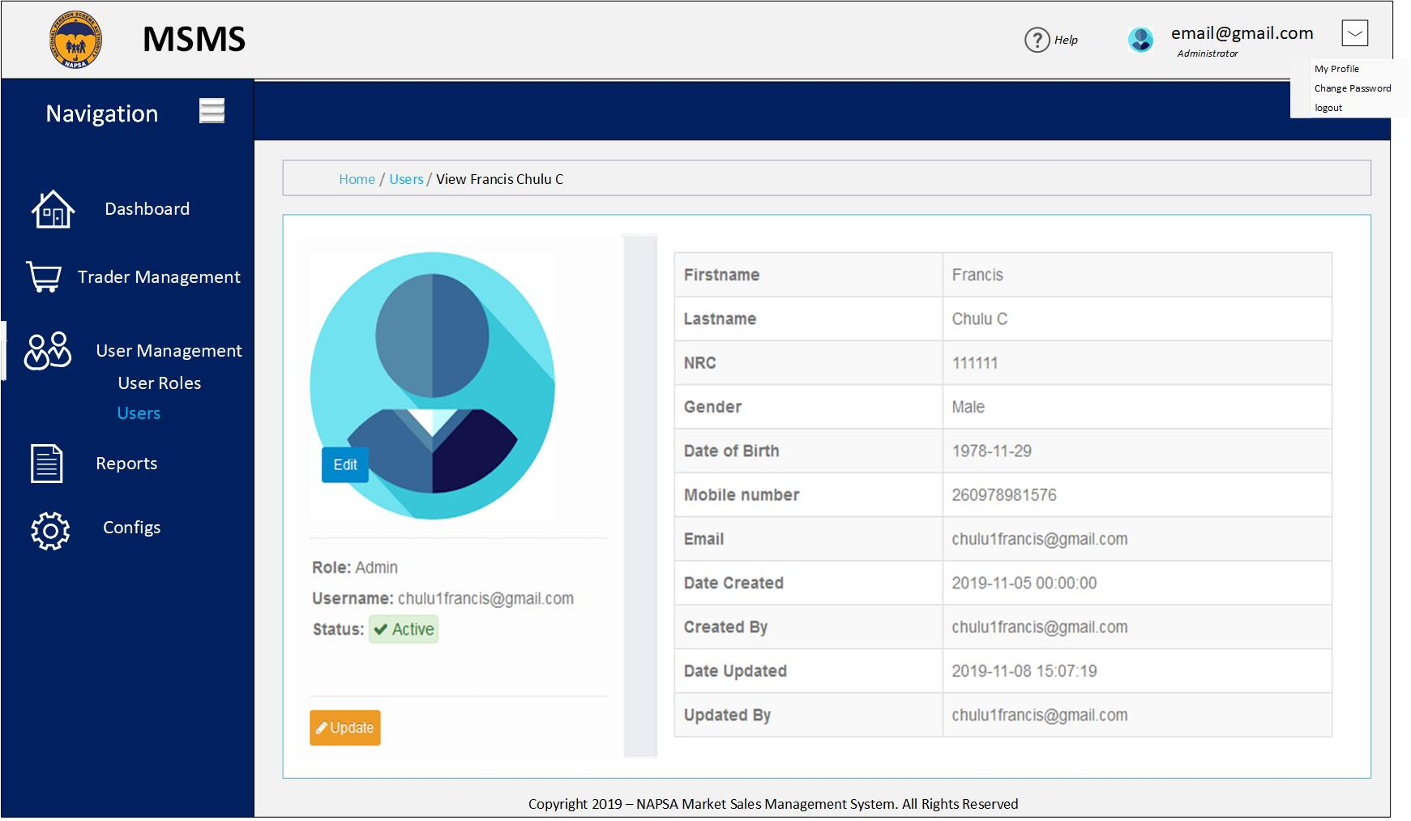

Fig. 4.0. View User screen.

* 1. TRADER MANAGEMENT MODULE

This module will be used to manage traders. Once a trader is registered by the probase systems, the Market administrator can block the trader from using the system or enable the trader again after they were disabled. The current use case does not allow the trader to be registered from the Market Sales System but the system has a button were a trader can be added should the use case be changed. The module will also provide the Market Administrators to be able to view trader sales/transactions. The system will show the status of the transaction and the status description of that transaction. Below wireframes shows screens a user will interact with when using the trader management module.

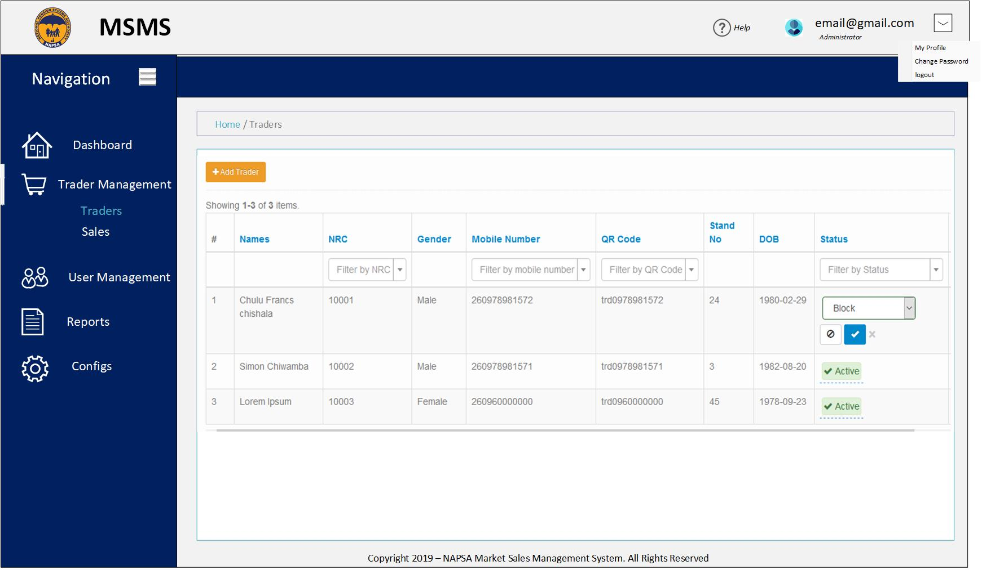

Fig. 4.1. Traders Screen

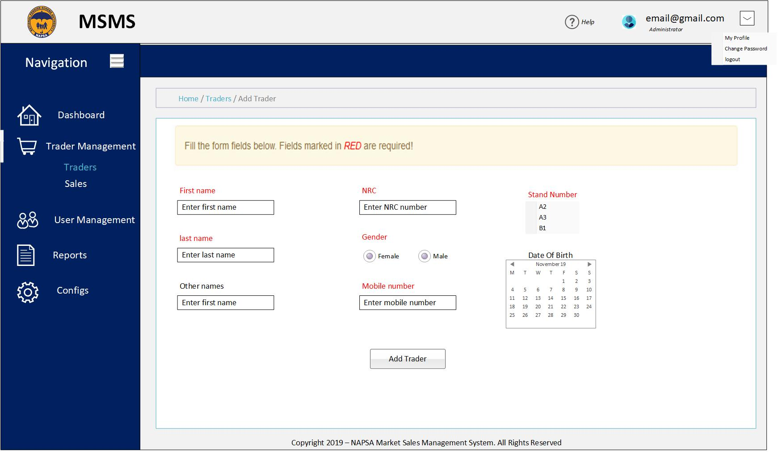

Fig. 4.2. Add Trader

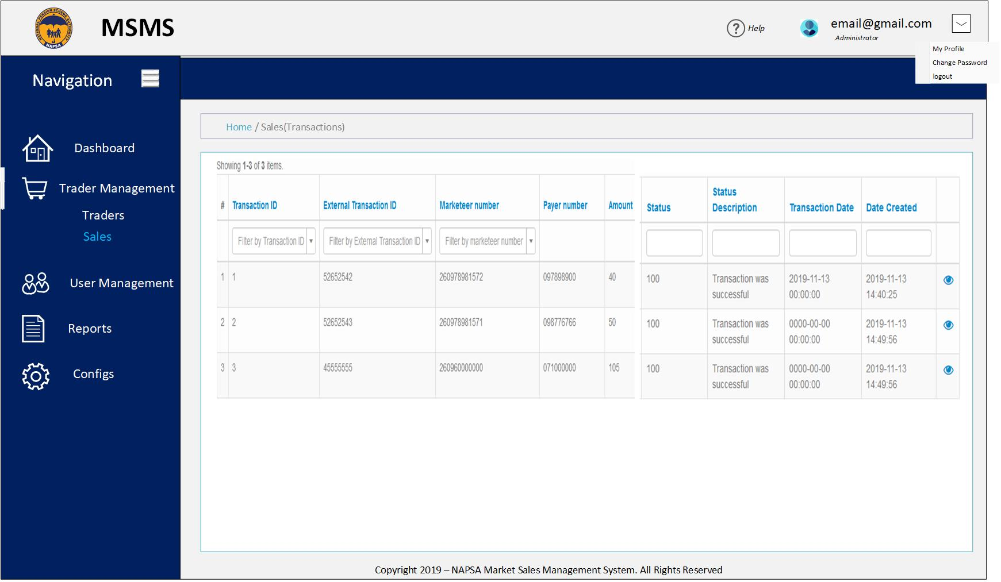

Fig. 4.3. Trader Sales/Transactions

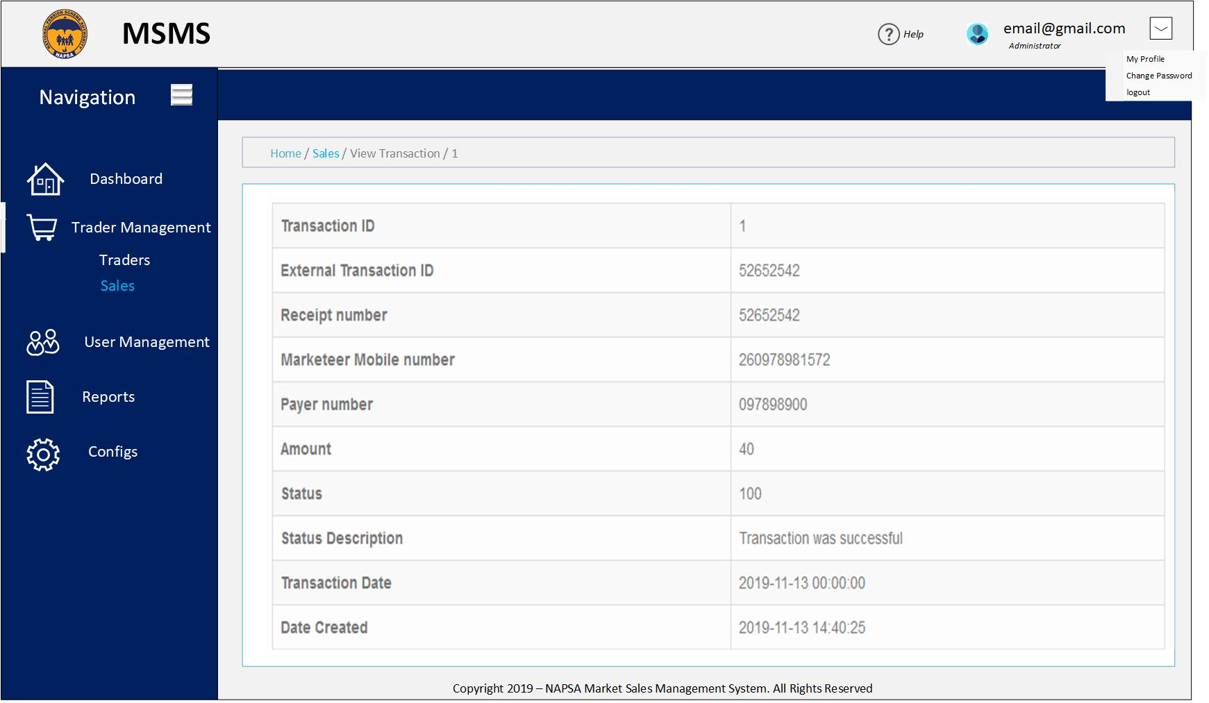

Fig. 4.4. View Trader Sale/Transaction

* 1. CONFIGURATIONS MODULE

This module will be used be System Administrators and Market Administrators to set certain configurations that the system will use. Some of the configurations that will be set will include but not limited to Market charges whose applicability will be defined from the system. Market notifications which will include notification messages to markets on issues concerning the market. The screen below shows some of the wireframes in this module.

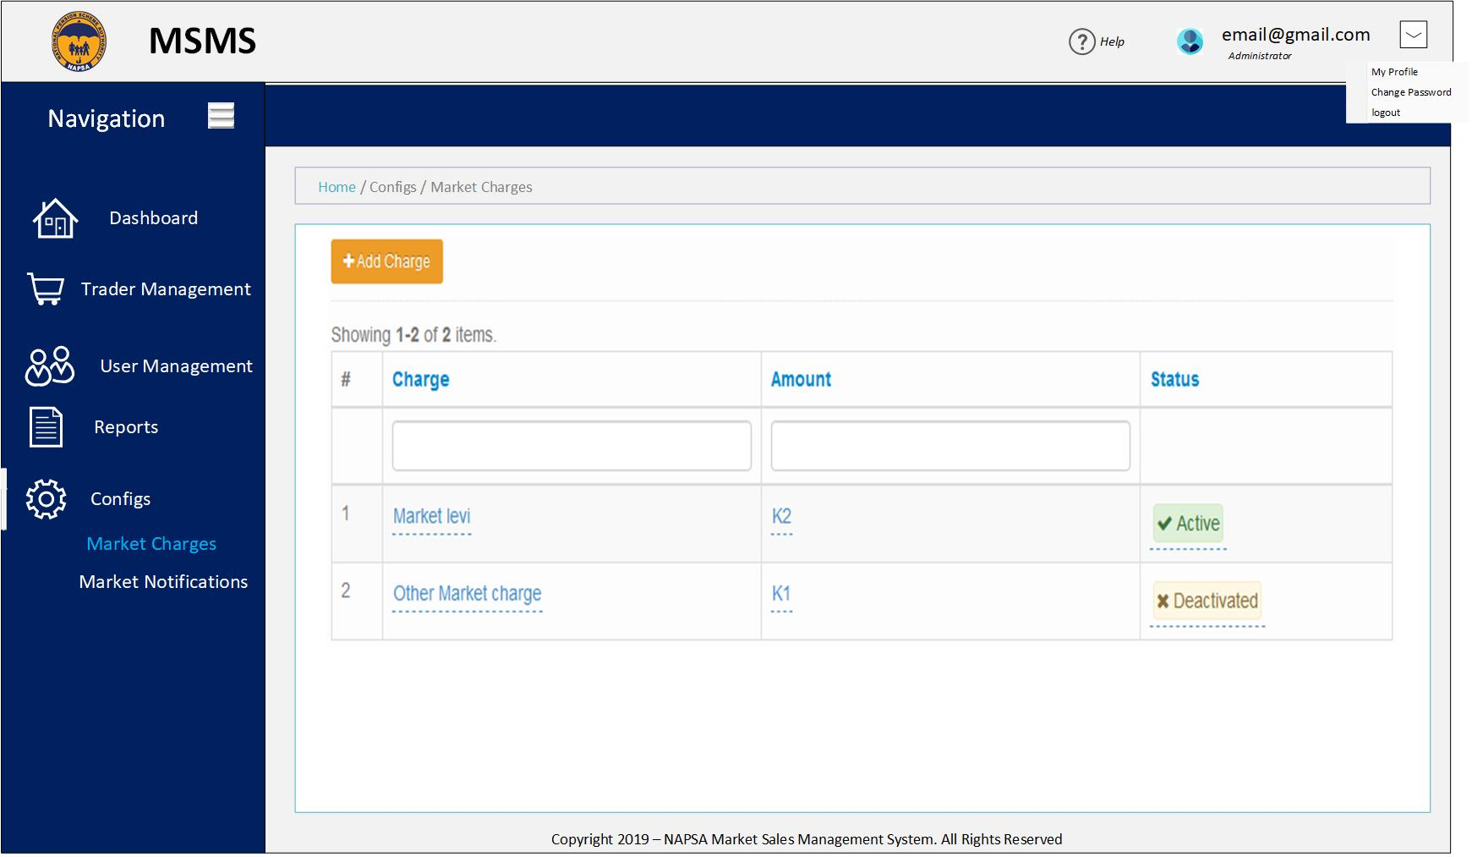

Fig. 4.5. Market Charges home screen

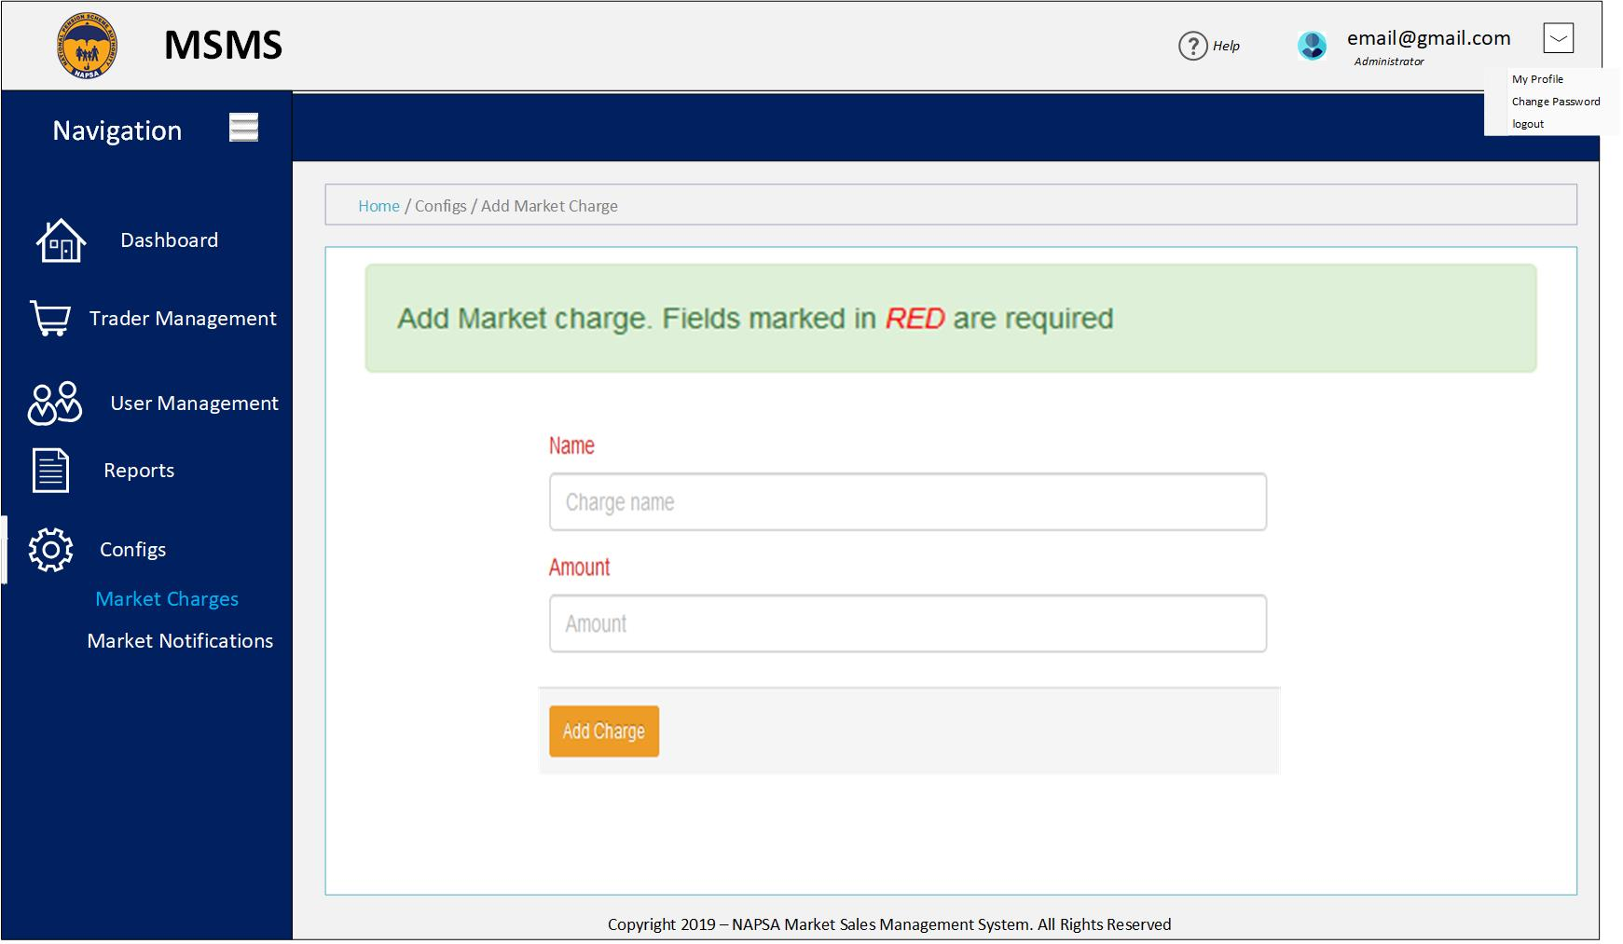

Fig. 4.6. Add Market Charge wireframe

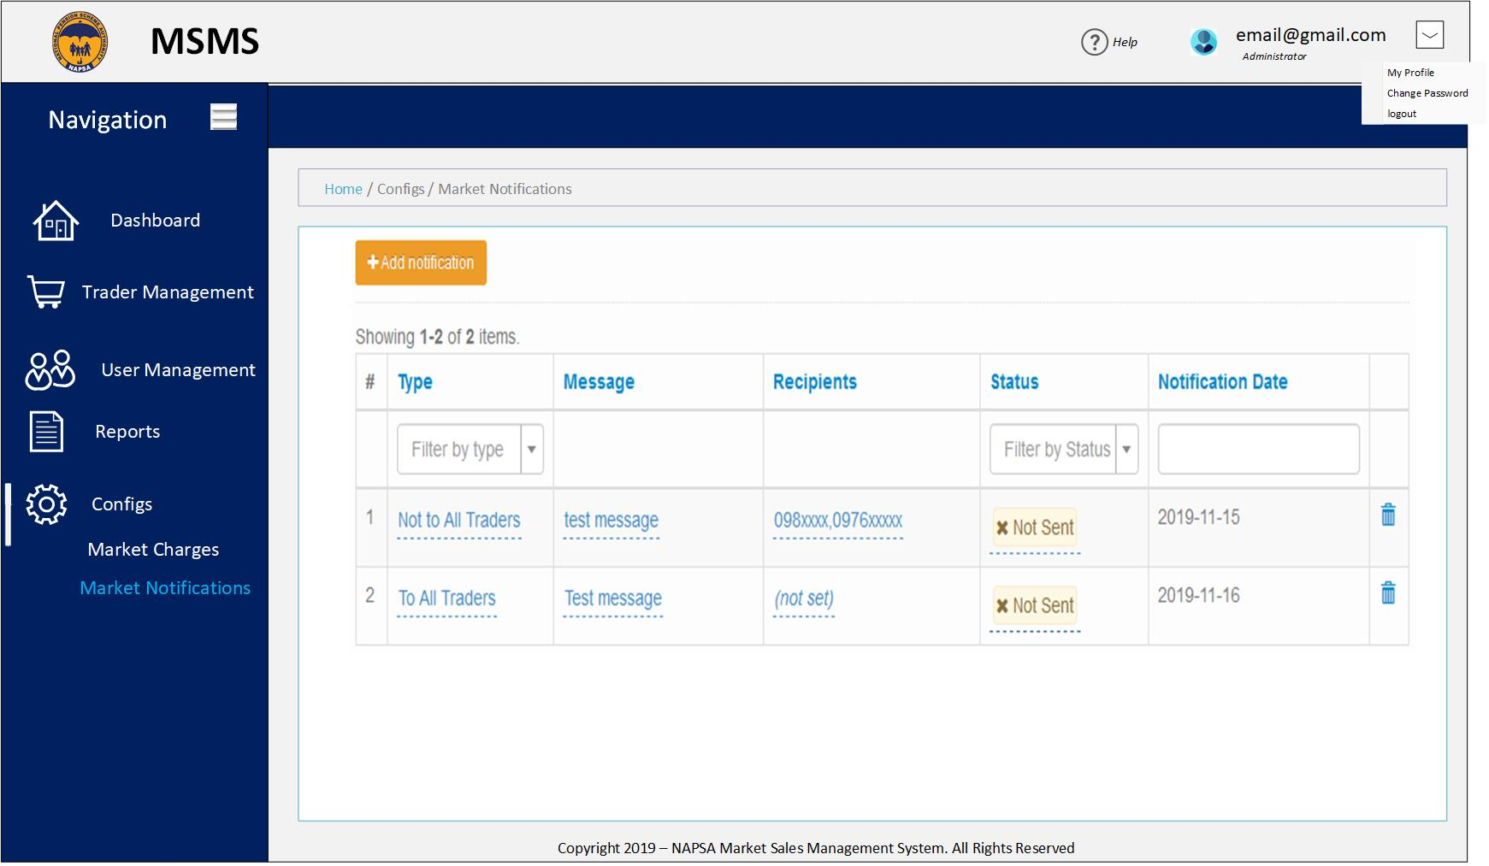

Fig. 4.7. Market Notifications

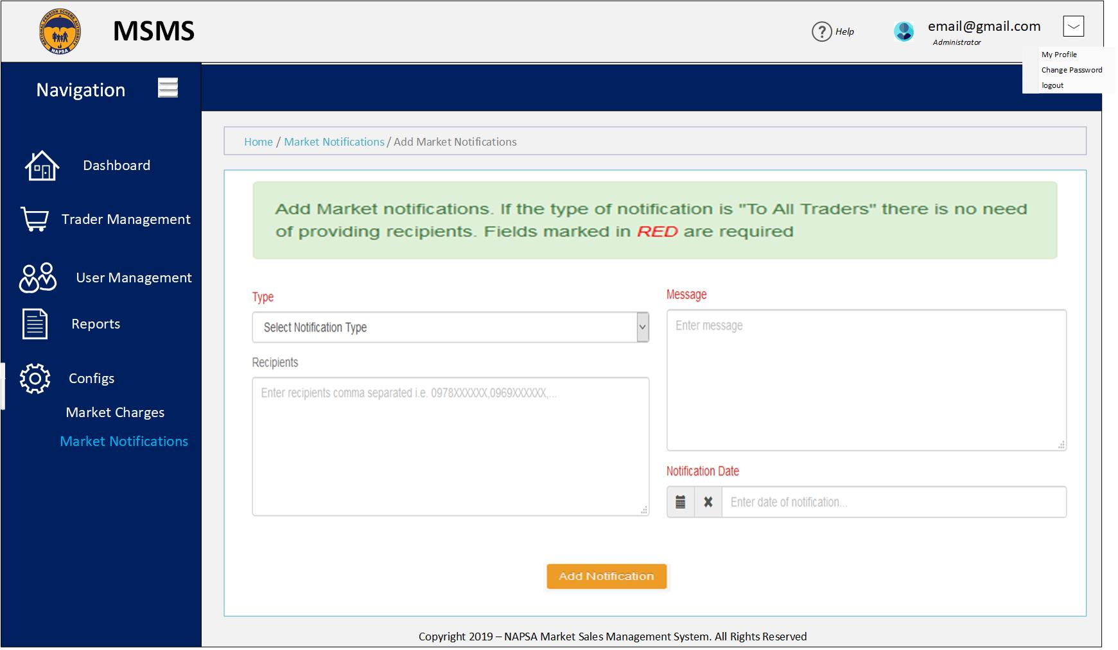

Fig. 4.8. Add Market Notification